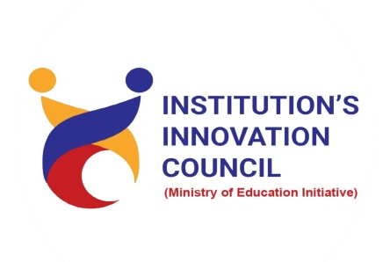
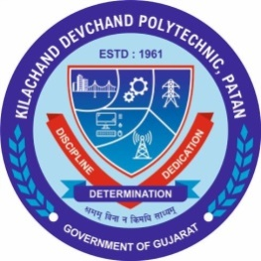

Student start-up research and innovation Cell

K. D. Polytechnic, Patan

“SSIP-Awareness program”

Date
01/02/2024
Tuesday
04:10 PM to5:10 PM

Program Report

- DETAILS OF PROGRAM
Title of Program: | SSIP Awareness program
Date: | 01/02/2024
Time: | 04:10 pm to 05:10 pm
Venue: | AB101
Event Coordinator | Mr. Hitesh T. Patel
Speakers: | Mr. Hitesh T. Patel  Lecturer, Electrical Engineering Dept. K. D. Polytechnic, Patan
Participant: | Final Year Students  K. D. Polytechnic, Patan  19 Students.

- Brief about program
The Student Start-up and Innovation Policy (SSIP) Cell at K. D. Polytechnic is dedicated to fostering a culture of innovation and entrepreneurship among students. Through workshops, mentorship, and networking opportunities, the SSIP Cell empowers students to pursue their entrepreneurial aspirations and contribute to economic growth.
- Glimpse of program
